**JAYPEE INSTITUE OF**

**INFORMATION**

**TECHNOLOGY, NOIDA**

B.TECH. III SEMESTER

SYNOPSIS PROJECT DSW



***DATABASE DESIGN FINAL PROJECT REPORT***

***CAB BOOKING SYSTEM***

Submitted by

|  |  |  |  |
| --- | --- | --- | --- |
| **S.No.** | **Enrollment No.** | **Name** | **Batch** |
| **1.** | **20103023** | **Aditi Mahabole** | **B1** |
| **2.** | **20103016** | **Muskan Mittal** | **B1** |
| **3.** | **20103018** | **Saksham Tyagi** | **B1** |
| **4.** | **20103009** | **Shubh Garg** | **B1** |
| **5.** | **20103020** | **Manika Agarwal** | **B1** |

Introduction :

In today’s era, everyone wants convenience and comfort in daily life activities but everywhere, it is not possible. Travelling is also a major part of day-to-day activities and in this case too, people want the same comfort in the journey. Taking this statement, we came to the solution that will provide the comfort as well as secure journey.

***QUICK CABS*** is a web application which lets you book cabs for travel purpose and provides you the best service that will make your journey more luxurious.

The objective of the project is to help customers go online and reserve any preferred kind of Cab they want, which is available at that time.

We have used **HTML/CSS/Javascript/BOOTSTRAP/PHP/MYSQL** for making this project . The software that we have used is XAMPP and VS CODE(as text editor).

ER MODEL:

Has

Payment

BOOKING

Car

Does

assign

DRIVER

PASSENGER

MAPPING:

**PASSENGER TABLE:**

|  |  |  |  |  |  |
| --- | --- | --- | --- | --- | --- |
| **P_ID** | P_FNAME | P_LNAME | P_EMAIL | P_PHONENO | Password |

**DRIVER TABLE:**

|  |  |  |  |  |  |  |
| --- | --- | --- | --- | --- | --- | --- |
| **D_ID** | D_NAME | D_ADDRESS | D_PHONENO | D_LICENSE | Pass | Availability |

**CAR:**

|  |  |  |  |  |
| --- | --- | --- | --- | --- |
| **CAR_NO** | MODEL | RCNUMBER | TYPE | AVAILABILITY |

**ASSIGN (RELATION TABLE):**

|  |  |
| --- | --- |
| **DRIVERID** | **CAR_NO** |

**BOOKING:**

|  |  |  |  |  |  |  |  |
| --- | --- | --- | --- | --- | --- | --- | --- |
| **BOOKING_NO** | BOARDING_OTP | BOARDING_POINT | DROPPING_POINT | BOOKING_TYPE | END_RIDE | **P_ID** | **D_ID** |

**PAYMENT:**

|  |  |  |  |  |
| --- | --- | --- | --- | --- |
| **PAYMENT_ID** | PAYMENT_TYPE | AMOUNT | P_BANKDETAILS | **BOOKING NO** |

Working And Features

The project consists of a home page , a login page, separate signup pages for driver and user , booking page ,user interface , driver interface and payment portal.

**Home page:**

The home page provides a user friendly interface and shows some features like the type of cabs you can choose from. It has buttons that take us to the login page or the booking page. The footer consists of ways to contact the administrator through various social media links.

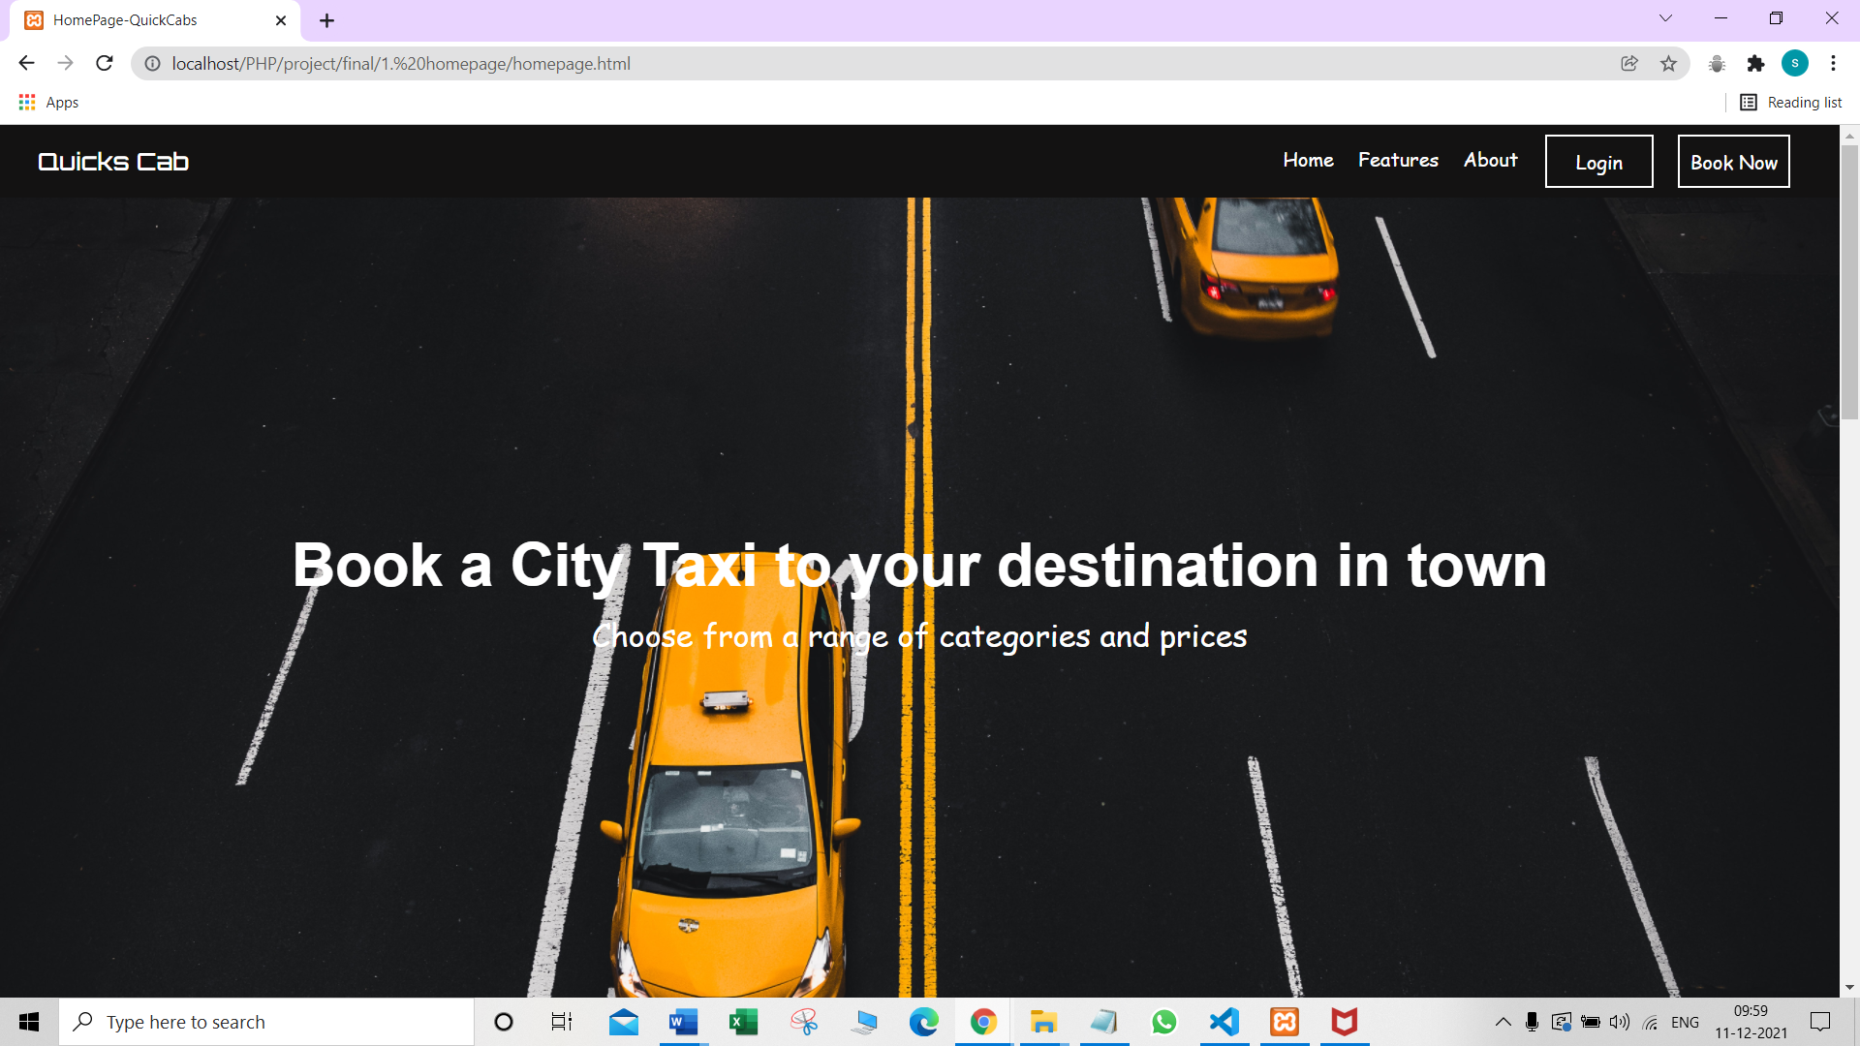

**Login page:**

A person can choose whether he wants to login as a user or a driver. In case , the person does not have an account , he can sign up through the driver sign up or user sign up page.After logging in , customer is taken to the booking page whereas the driver is redirected to the driver interface.

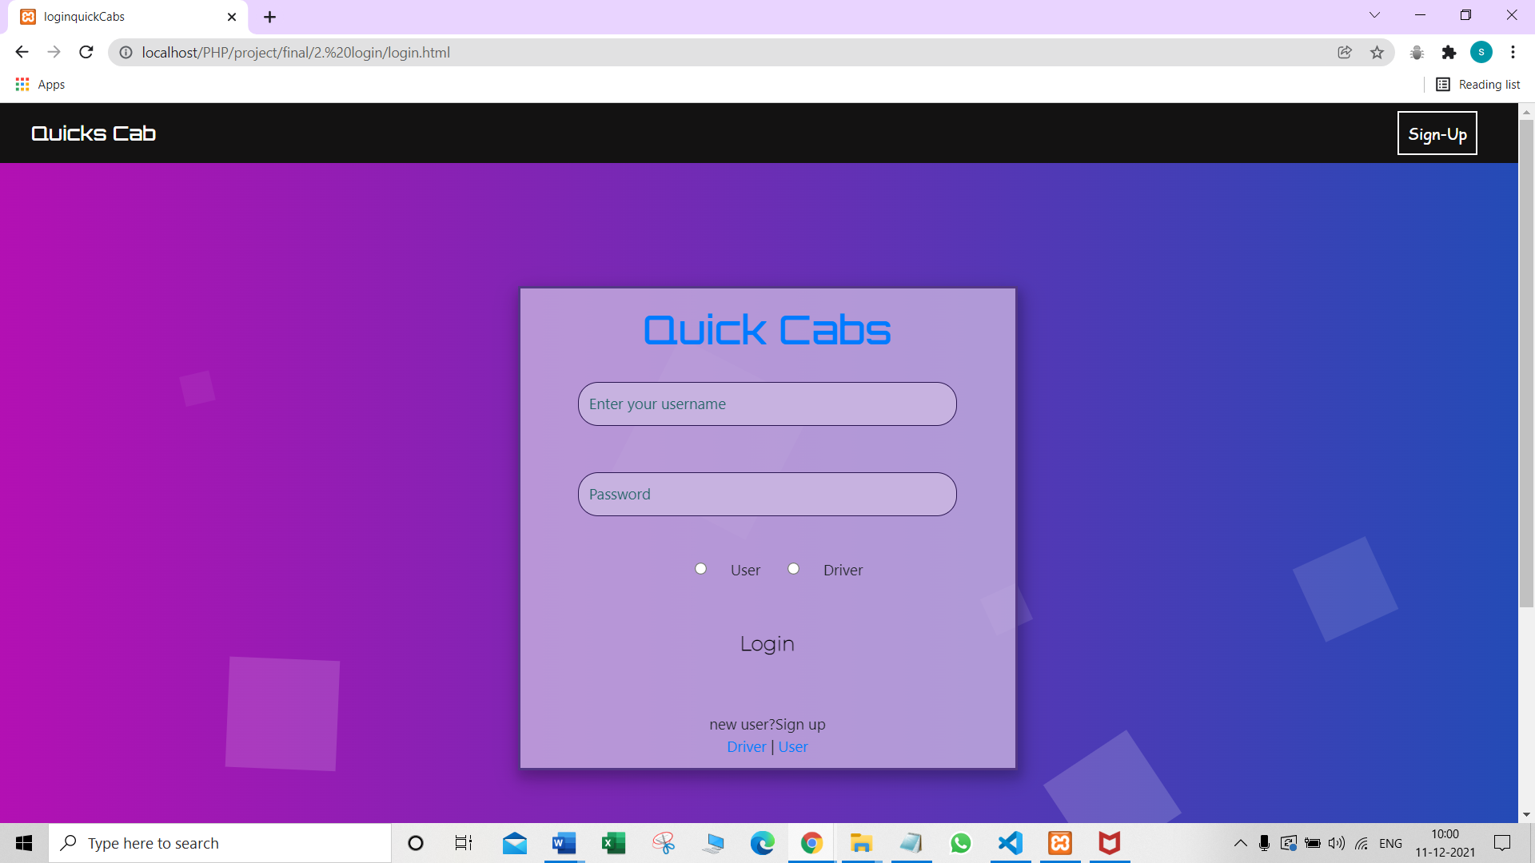

**Sign Up pages:**

These pages take information from the user and creates their account. When a person signs up as a driver , he is allotted a car number too.

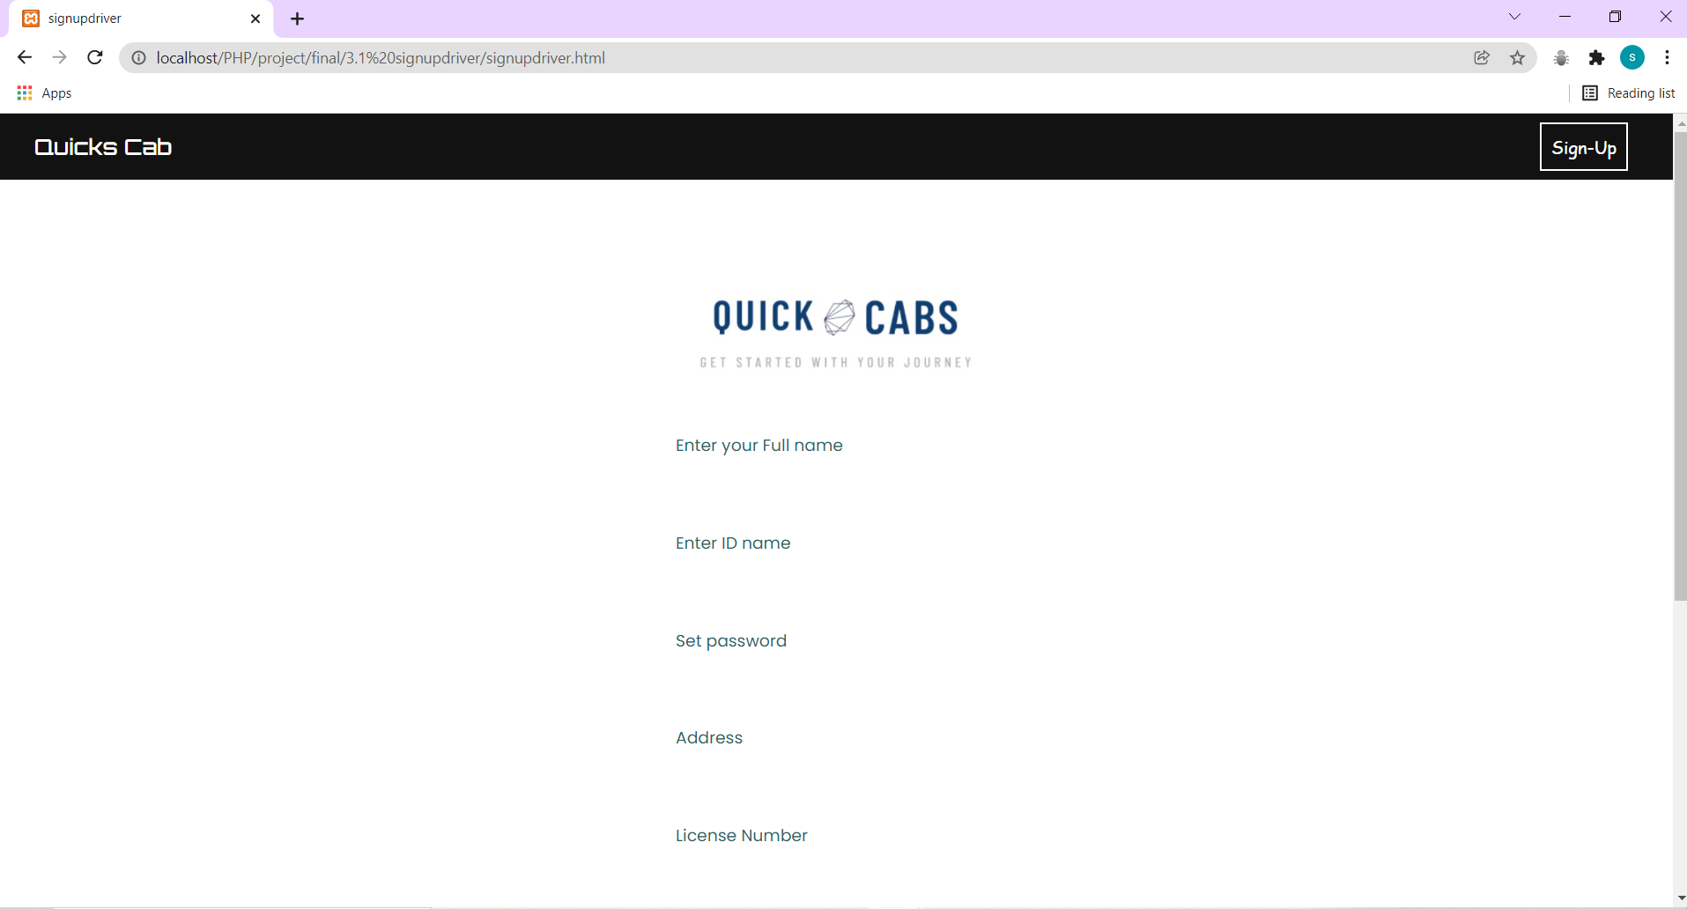

**Booking page:**

A person can book a cab to travel within the city , outstation , or even rent it. The bill will be calculated based on distance in case of city or outstation booking (including extra charges). The cost will be different for different types of cabs that is auto mini or macro. After booking is done , the user will be taken to the user interface page.

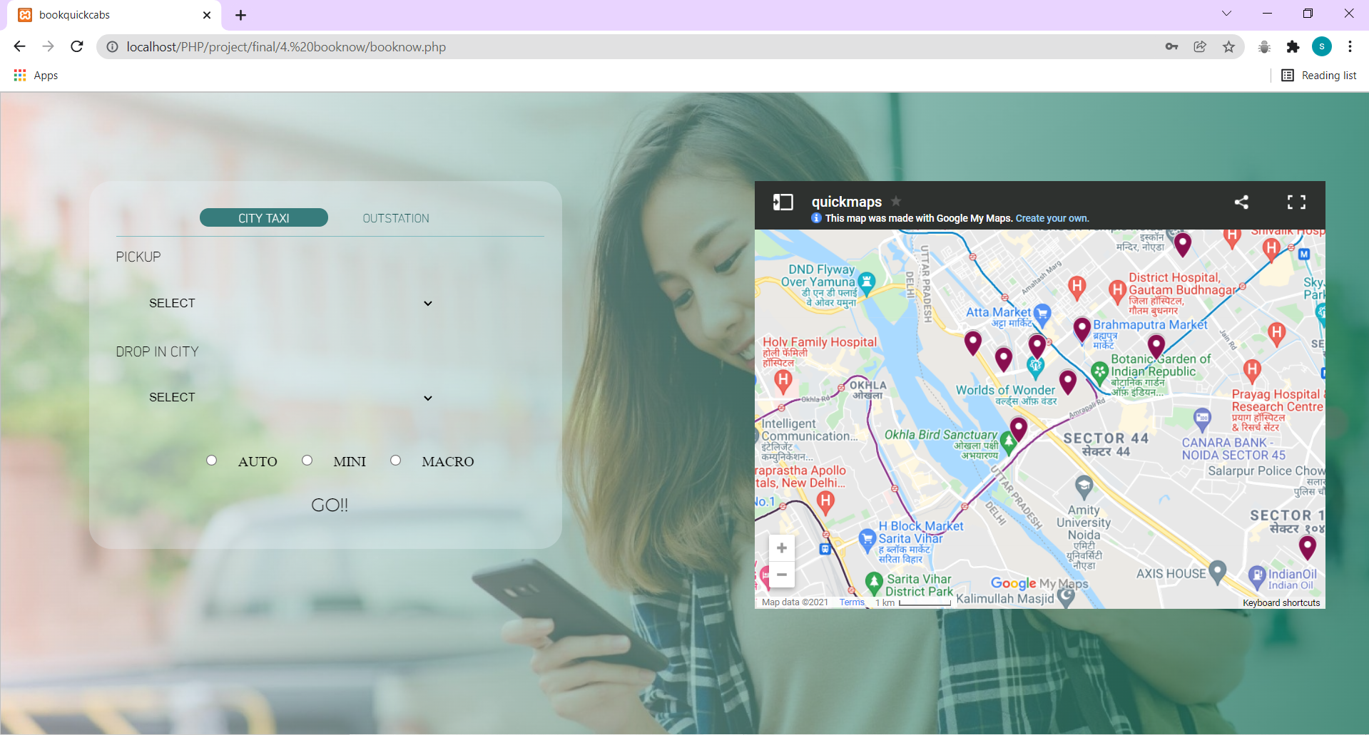

**User-Interface:**

Before the ride has started, this page will display to the user the details of his driver , car , contact details , drop and pickup location. It will also show a generated OTP which the passenger has to give to the driver for the ride to start. In addition to this , this page also displays the details of the passenger himself.

After the ride has started , the driver details will be replaced by a simple message that shows that the ride has started.

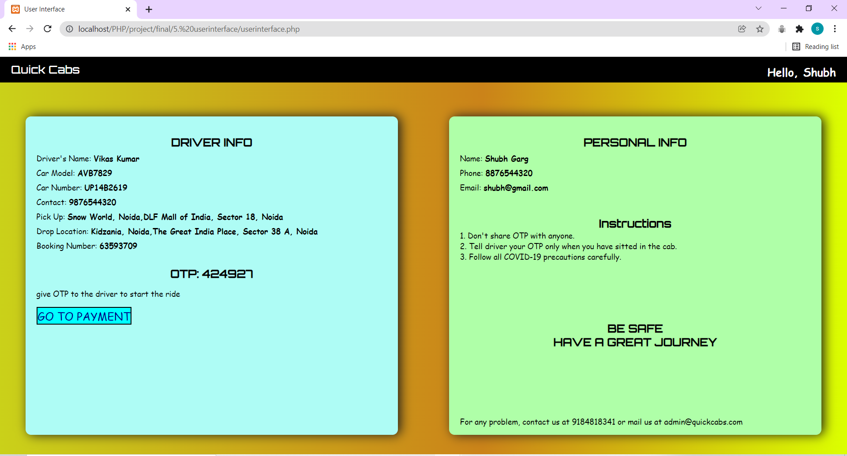

**Driver-Interface**

When a driver logs in , he is taken to the driver interface. It displays his information , details of the car , and few instructions. It also informs the driver in case no passenger has been assigned to him yet.

When a passenger is assigned to a driver , he gets a text field that asks for the OTP. If the entered OTP matches the one assigned to the passenger , the ride can be started and an end ride button appears. After the ride ends, the page shows the amount to be paid by the customer to the driver . After a little time, it again informs the driver that no customer has been allotted to him yet, whereas the passenger is taken to the payment portal.

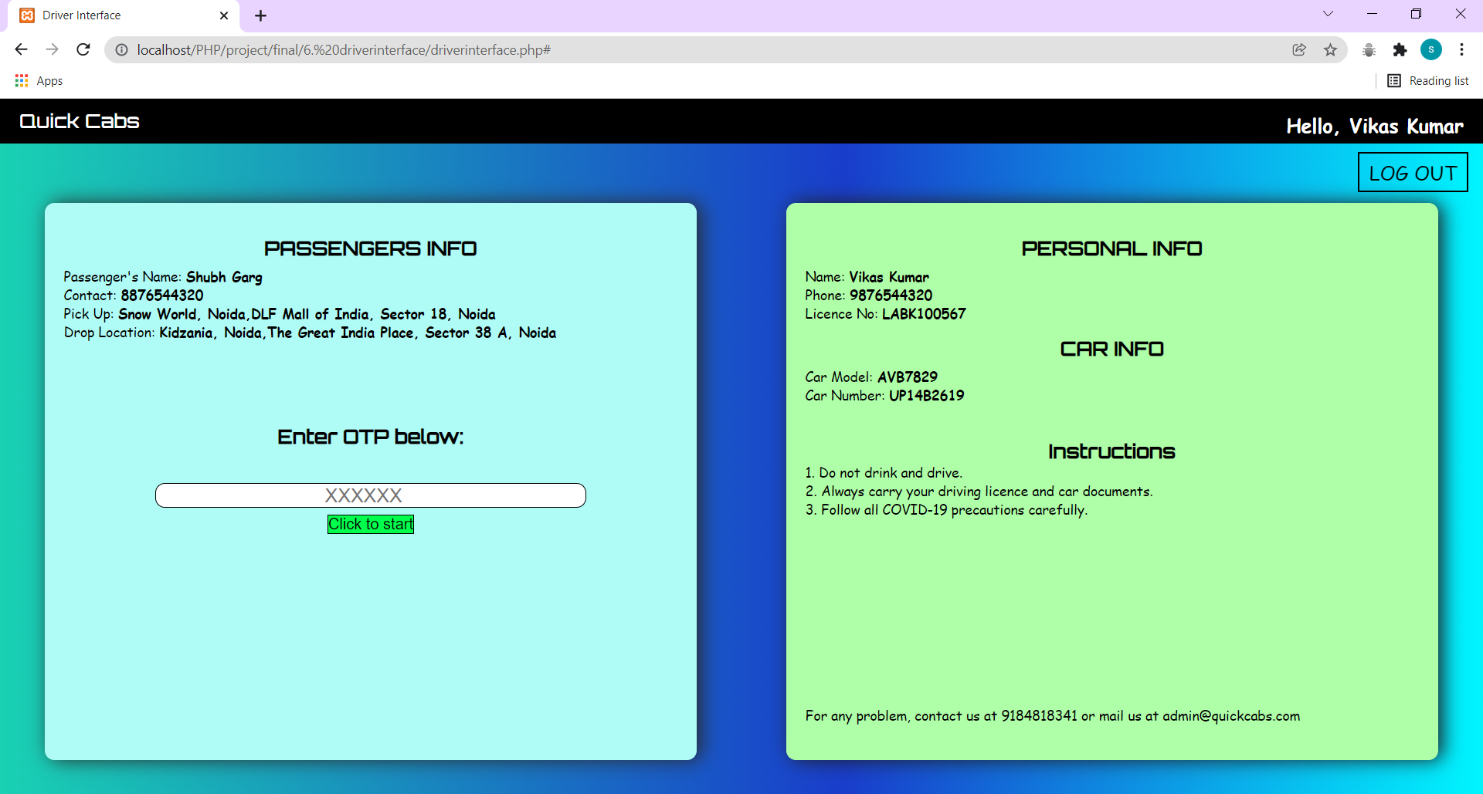

**Payment Portal:**

After the ride ends , the passenger is taken to the payment portal. Here , a generated payment id is shown to him , along with the amount to be paid.

If the customer chooses to pay via cash , he can simply choose the option and pay the amount to the driver.

In case that he wants to pay through a card, he has to enter his card details and the relevant amount will be deducted from his account.

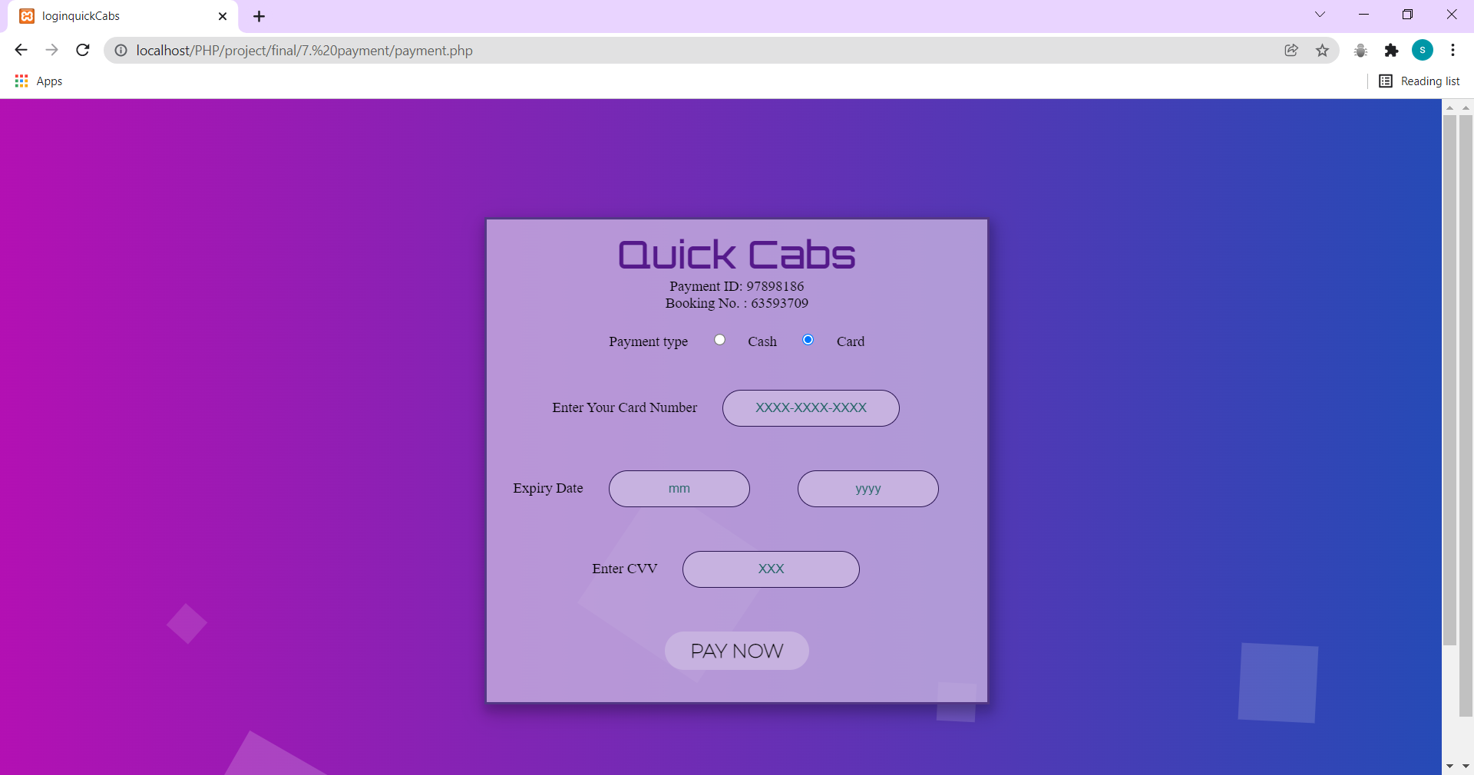

**NORMALIZATION:**

Out tables are already in the normalised form they follow the rules   
of 1NF, 2NF ,3NF ,BCNF.

Passenger table :

P_ID🡪P_FNAME

P_ID🡪P_LNAME

P_ID🡪P_EMAIL

P_ID🡪P_PHONENO

P_ID🡪Password

Driver table:

D_ID🡪D_NAME

D_ID🡪D_ADDRESS

D_ID🡪D_PHONENO

D_ID🡪D_LICENSE

D_ID🡪Pass

D_ID🡪Availability

Car table:

CAR_NO🡪MODEL

CAR_NO🡪RCNUMBER

CAR_NO🡪TYPE

CAR_NO🡪AVAILABILITY

Booking table:

BOOKING_NO🡪BOARDING_OTP

BOOKING_NO🡪BOARDING_POINT

BOOKING_NO🡪DROPPING_POINT

BOOKING_NO🡪BOOKING_TYPE

BOOKING_NO🡪ENDTIME

BOOKING_NO🡪P_ID

BOOKING_NO🡪D_ID

Payment table :

PAYMENT_ID🡪PAYMENT_TYPE

PAYMENT_ID🡪AMOUNT

PAYMENT_ID🡪VOUCHER

PAYMENT_ID🡪P_BANKDETAILS

PAYMENT_ID🡪BOOKING NO

* 1NF: There should be no multi values.
* 2NF: All non-prime attributes are fully functionally dependent on respective Primary keys.
* 3NF: No non-prime attribute is dependent on other non-prime attribute in respective tables .
* BCNF: Left part should only have prime attributes which it follows.

Conclusion:

OUR TABLE IS **NORMALISED.**

**SCREENSHOTS (EXAMPLE EXECUTED DURING PROJECT VIVA):**

**ALL TABLES IN DATABASE:**

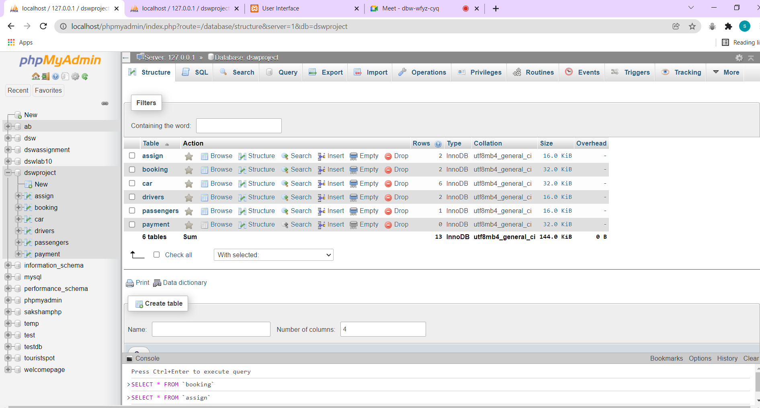

**TABLES BELOW**

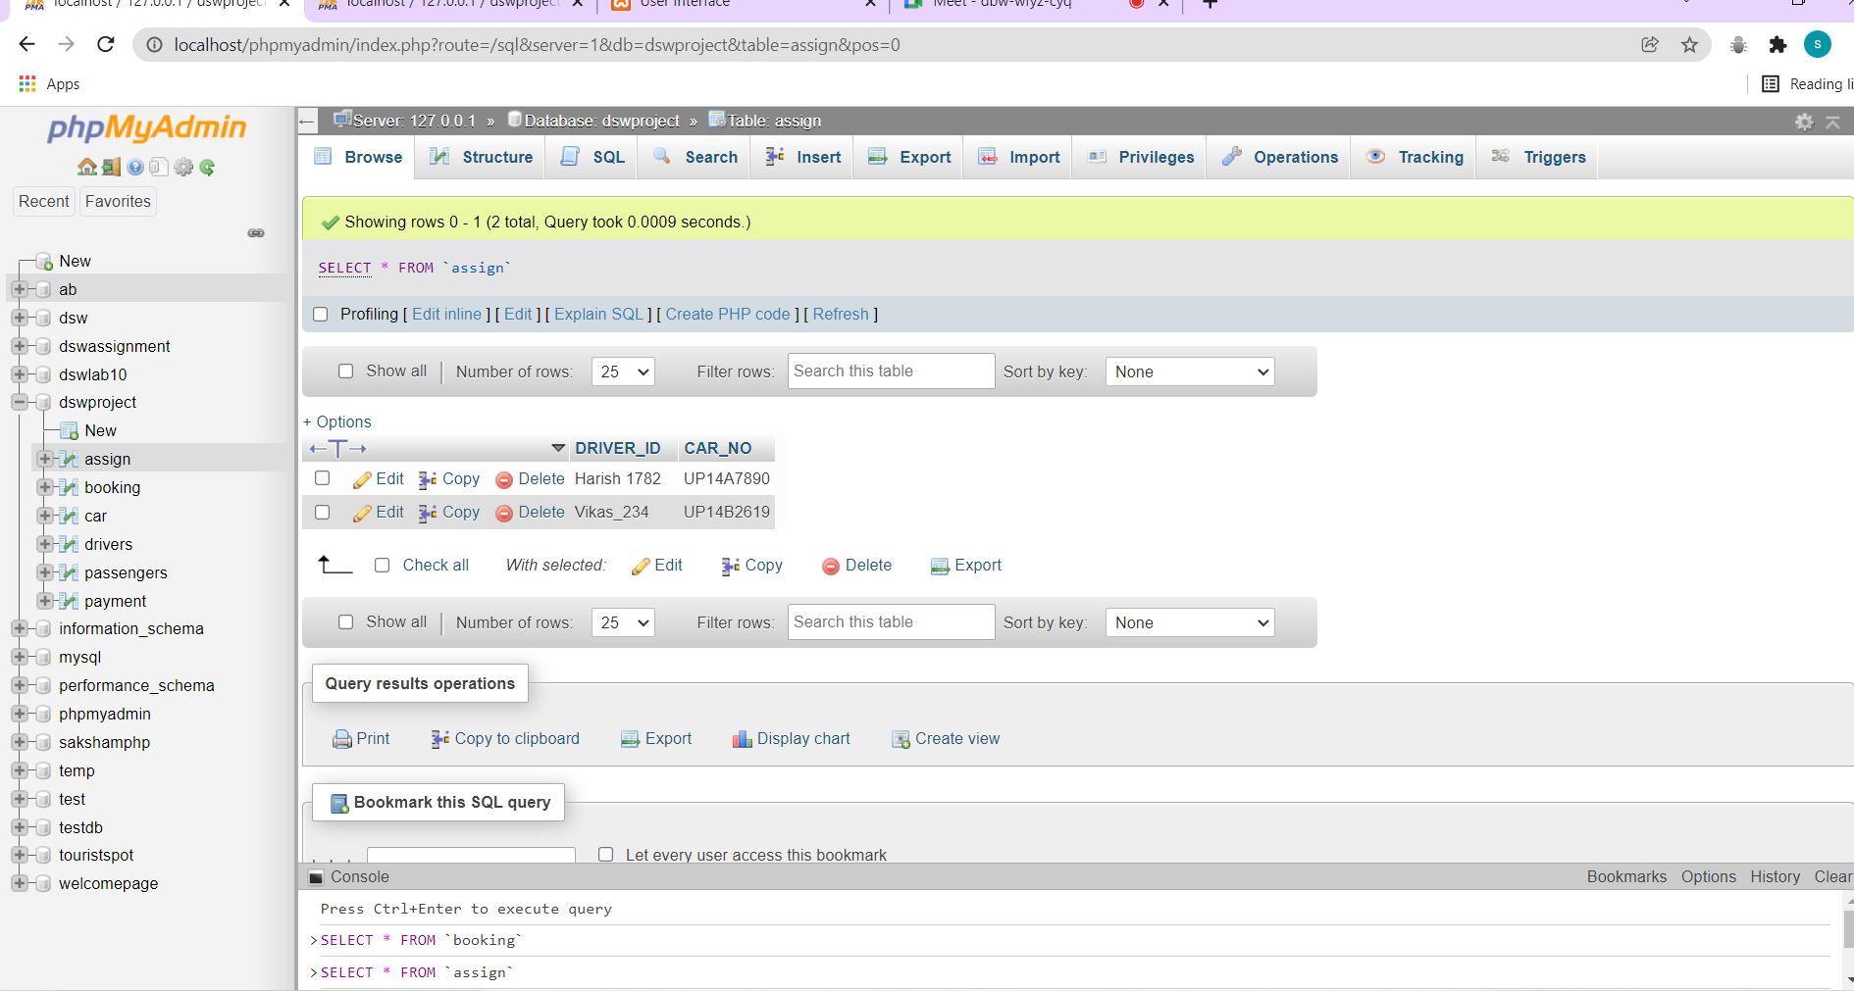

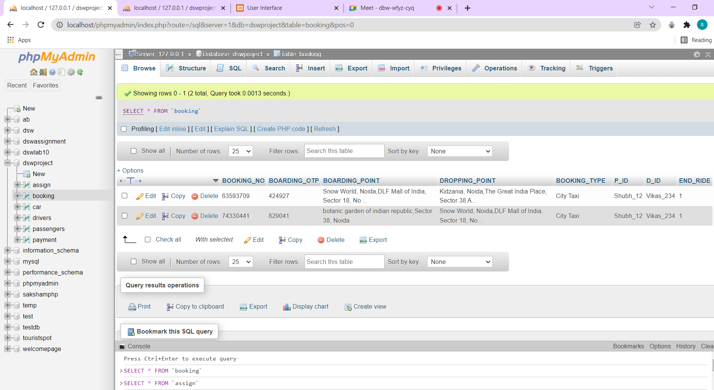

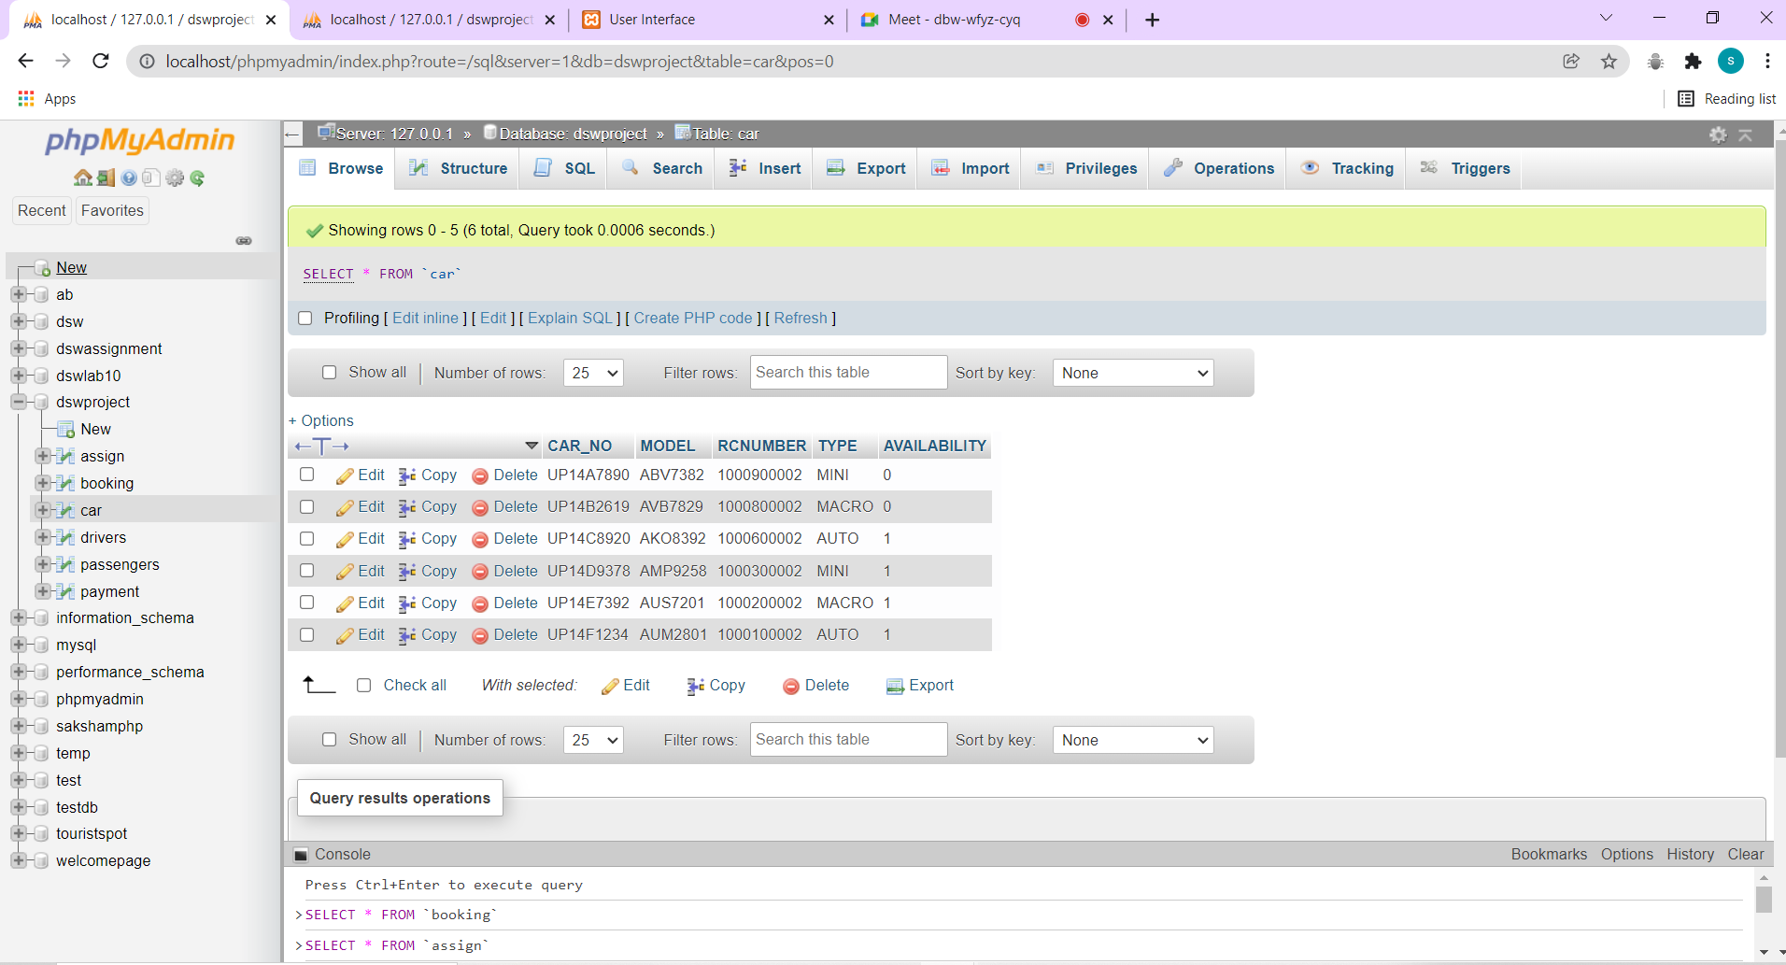

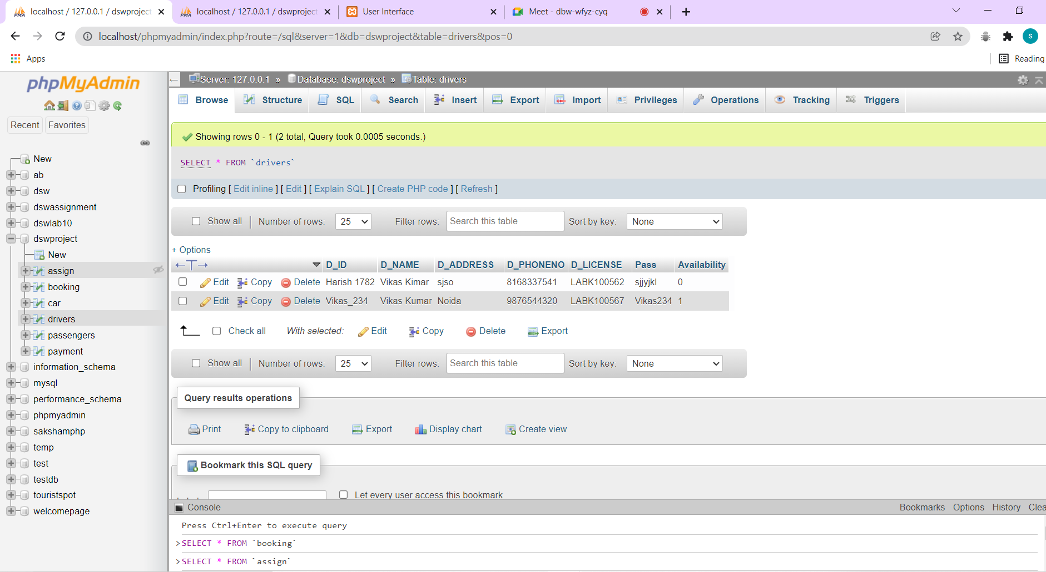

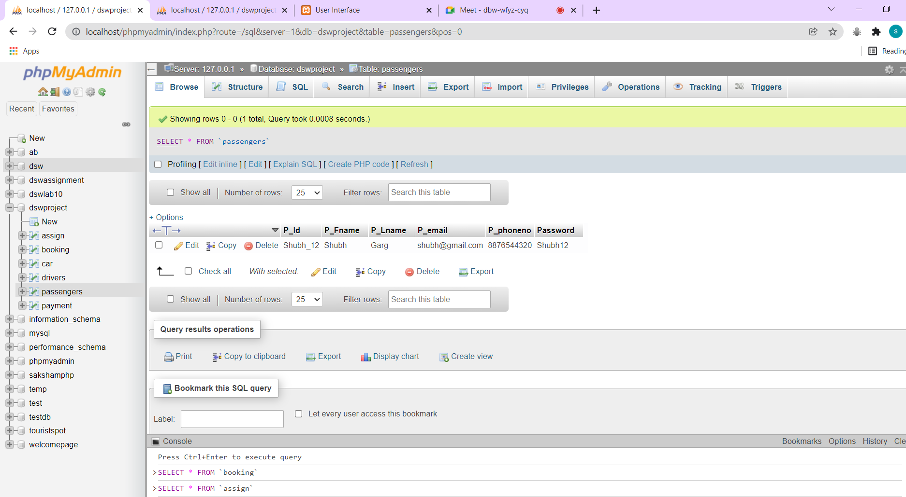

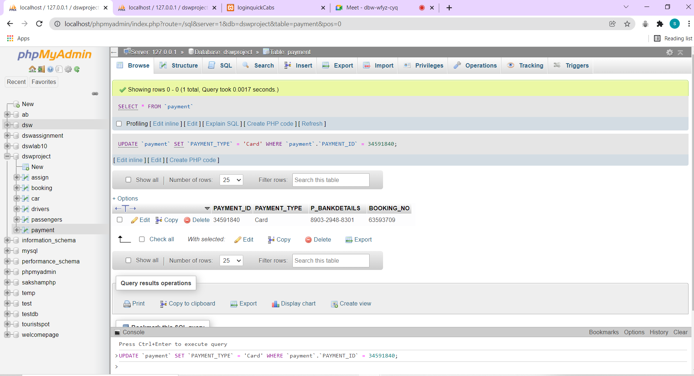

EXTRA SCREENSHOTS

